**ZYGO Hardware Changes**

The Zygo Chassis is shown below

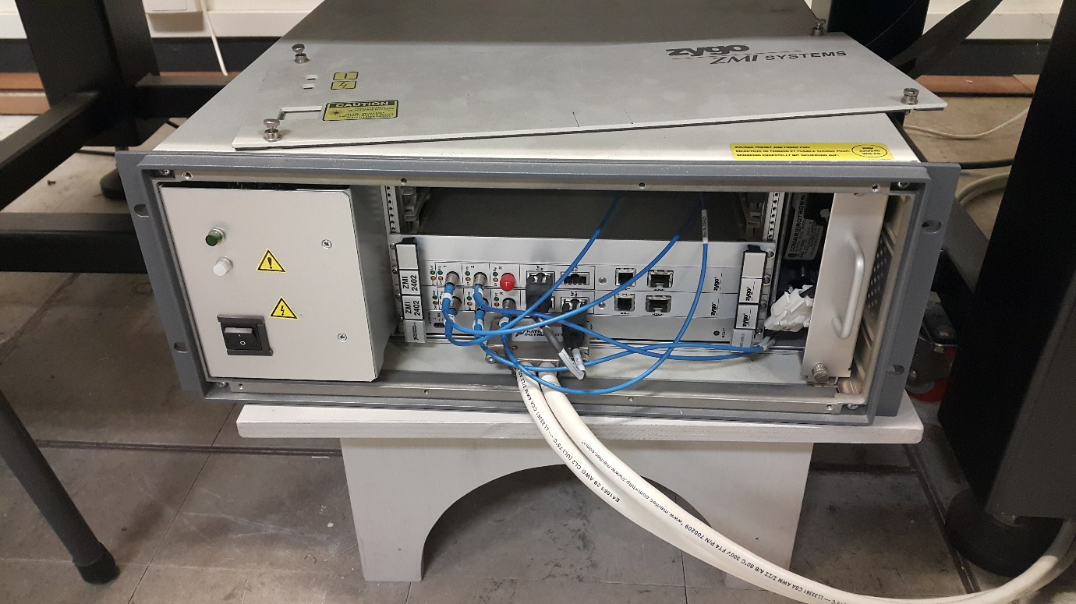

|  |
| --- |
| Empty space for Card6 ZMI-2402 |
| Empty space for Card5 ZMI-2402 |
| Empty space for Card4 ZMI-2402 |
| Empty space for Card3 ZMI-2402 |
| Card2 ZMI-2402 |
| Card1 ZMI-2402 |
| VME-MXI-2 |

**ZMI-2402 Settings**

**SW8**

|  |  |  |  |  |  |  |  |  |  |  |  |  |
| --- | --- | --- | --- | --- | --- | --- | --- | --- | --- | --- | --- | --- |
| Bit | 11 | 10 | 9 | 8 | 7 | 6 | 5 | 4 | 3 | 2 | 1 | 0 |
| SW | **1** | **2** | **3** | **4** | **5** | **6** | **7** | **8** | A3 |  |  |  |
| Card1 | **off** | **off** | **off** | **off** | **on** | **on** | **on** | **on** |  |  |  |  |
| Card2 | **off** | **off** | **off** | **off** | **on** | **on** | **on** | **off** |  |  |  |  |
| Card3 | **off** | **off** | **off** | **off** | **on** | **on** | **off** | **on** |  |  |  |  |
| Card4 | **off** | **off** | **off** | **off** | **on** | **on** | **off** | **off** |  |  |  |  |

**SW6**

|  |  |  |  |  |  |  |  |  |  |  |
| --- | --- | --- | --- | --- | --- | --- | --- | --- | --- | --- |
| SW | **1** | **2** | **3** | **4** | **5** | **6** | **7** | **8** | **9** | **10** |
| Card1 to Card (N-1) | **on** | **on** | **on** | **on** | **on** | **on** | **on** | **on** | **on** | **on** |
| Card N: Last Card  The one on top  Card2 in the picture above | **on** | **on** | **on** | **on** | **on** | **on** | **off** | **on** | **on** | **on** |

**Useful Information used to develop the ZYGO Simulink Blocks**

**P2 Base Address**

CARD1 axis1: 0xF00

CARD1 axis2: 0xF08

CARD2 axis1: 0xF10

CARD2 axis1: 0xF18

CARD3 axis1: 0xF20

CARD3 axis1: 0xF28

CARD4 axis1: 0xF30

CARD4 axis1: 0xF38

**Connection Map**

|  |  |
| --- | --- |
| **P2 Bus** | **Digital input/Output** |
| P2_A0 | DO0 |
| P2_A1 | DO1 |
| P2_A2 | DO2 |
| P2_A3 | DO3 |
| P2_A4 | DO4 |
| P2_A5 | DO5 |
| P2_A6 | GND |
| P2_A7 | GND |
| P2_A8 | Internally Pulled up to +5V |
| P2_A9 | Internally Pulled up to +5V |
| P2_A10 | Internally Pulled up to +5V |
| P2_A11 | Internally Pulled up to +5V |
| P2_R/W* | +5v |
| P2_IOE* | Do6 |
| P2_SCLK1 | DO7 |
| P2 |  |
|  |  |
|  |  |
|  |  |
|  |  |
|  |  |
|  |  |
|  |  |
|  |  |
|  |  |
|  |  |